STAR TOPOLOGY

Step 1 : Take several PC’s and a switch

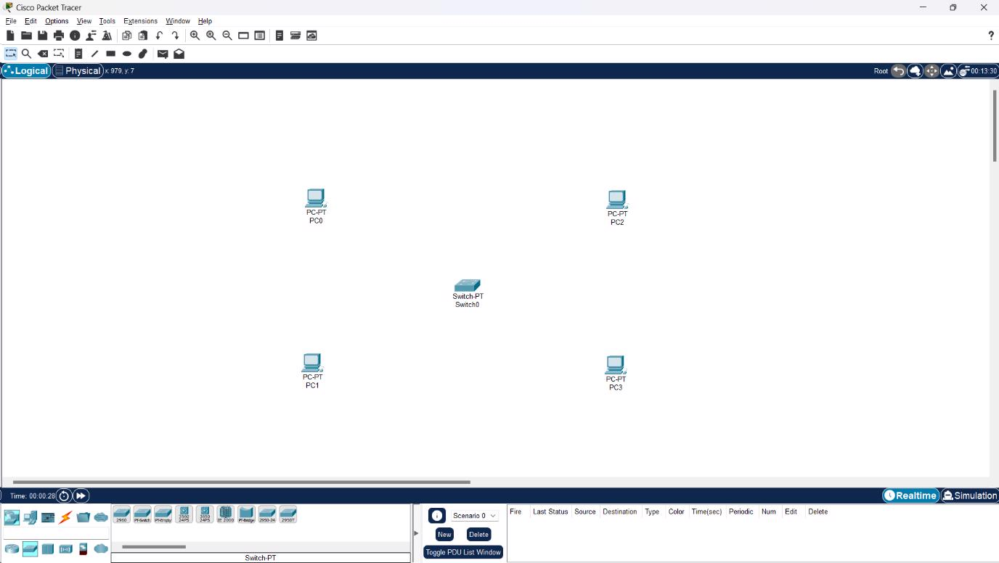

Step 2 : Link them

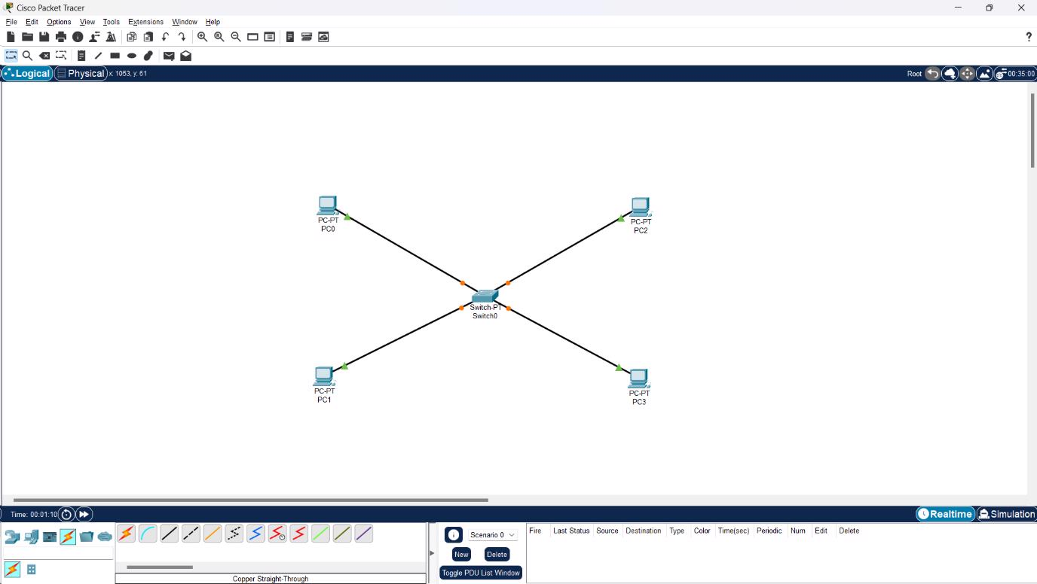

Step 3 : Provide IP address to each PC

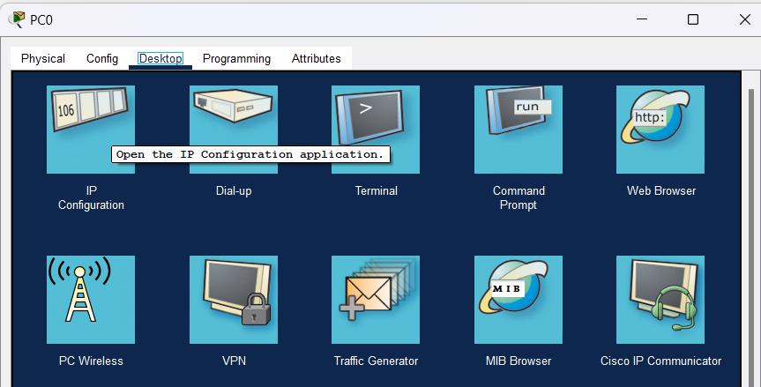

Step 5 : Transfer message from one device to another and check the status

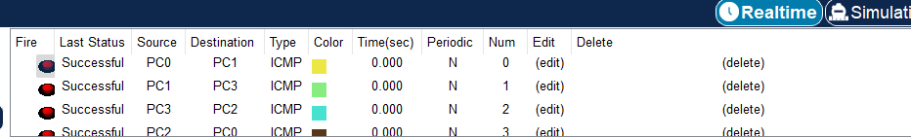

Step 6 : Run the ping command

